Cairdeas Community Childcare Centre Child Safeguarding Statement

- NAME OF SERVICE AND ACTIVITIES PROVIDED

Cairdeas is a registered pre-school providing the following services for children aged 6 months to 13 years: full day care for babies and preschool children; 4 ECCE preschool rooms; afterschool service and out of school service.

The management structure is outlined in the following diagram:

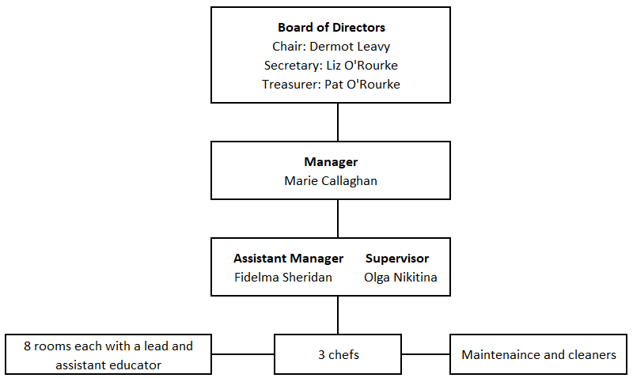

2.COMMITMENT TO SAFEGUARD CHILDREN FROM HARM

- Cairdeas is committed to safeguarding the children in our care and to providing a safe environment in which they can play, learn and develop.
- We believe that the welfare of the children attending Cairdeas is paramount. We are committed to child-centred practice in all our work with children.
- We are committed to upholding the rights of every child and young person who attends our service, including the rights to be kept safe and protected from harm, to be listened to and heard.
- Our policy and procedures to safeguard children and young people reflect national policy and legislation and are underpinned by Children First: National Guidance for the Protection and Welfare of Children 2017; Tusla children First – Child Safeguarding Guide 2017; and the Children First Act 2015.
- Our policy declaration applies to all paid educators, volunteers, board members and students on work placement within our organisation. All board members, educators, volunteers and students must sign up to and abide by the policies, procedures and guidance encompassed by this policy declaration and our child safeguarding policy and accompanying procedures.
- We will review our child safeguarding statement and accompanying child safeguarding policies and procedures every 2 years, or sooner if necessary due to service issues or changes in legislation or national policy.

Designated Liaison Person for Child Protection:
DLP | Deputy
Marie Callaghan 085 7294311 | Fidelma Sheridan 044 9379346  Olga Nikitina 044 9379346
3. RISK ASSESSMENT

In accordance with the Children First Act 2015, the Board of Management in conjunction with the manager has carried out an assessment of any potential for harm to a child while attending Cairdeas or participating in Cairdeas activities. A written assessment setting out the areas of risk identified and our procedures for managing those risks is summarised below:

Risk identified | Policies and/or Procedures in place to manage Risk
Unauthorised persons collecting children | Arrivals & Departures Policy  Child Registration Form – only those names on registration form allowed to collect child.  Visitors must sign visitors book at reception
Inappropriate control of children’s behaviours | Positive Behaviour Management Policy
Child missing when leaving school for Cairdeas | Procedure for collecting children from school  Appropriate educators: child ratios observed
Recruitment of Educators | Recruitment Policy & Induction Procedure to be updated to reflect new Children First Guidance 2017

4. CHILD SAFEGUARDING POLICIES AND PROCEDURES

As required by the Children First Act, 2015, Children First National Guidance for Protection and Welfare of Children 2017 and the Guidance for Developing a Child Safeguarding statement for Early Years Services 2018, the following safeguarding policies/procedures/measures are in place:

The policies identified in point 3 above were updated on 27th January 2023

Procedures to maintain a list of mandated persons under the Children First Act, 2015 to protect all children from harm by abuse.

A Relevant Person has been appointed.

A Designated Liaison Person and Deputies have been appointed.

Child Protection and Welfare Reporting Procedures

Confidentiality Policy

Policy for Dealing with Allegations of Abuse or Neglect Against Employees

Procedure for Managing Child Protection Records

Recruitment Policy

Garda Vetting Policy

Code of Behaviour for Working with Children

Induction Policy (which includes procedures to inform new educators about the Child Safeguarding Statement and accompanying safeguarding policies and procedures and Children First 2015).

All educators have completed the Tusla eLearning module – Introduction to Children First and relevant educators have attended Children First Child Protection Training.

Educators have access to regular Supervision and Support in line with the service policy.

Complaints Policy

Policy for Managing Outings

Policy for Managing Accidents and Incidents

Social Media Management Policy

5. IMPLEMENTATION AND REVIEW

We recognise that implementation is an ongoing process. Our service is committed to the implementation of this Child Safeguarding Statement and the accompanying child safeguarding policies and procedures that support our intention to keep children safe from harm while attending Cairdeas.

This Statement will be reviewed every 2 years or as soon as practicable after there has been a material change in any matter to which the statement refers.

This Statement has been published on the service website and is displayed in the centre. It has been provided to all educators, volunteers and any other persons involved with Cairdeas. It is readily accessible to parents and guardians on request. A copy of this Statement will be made available to Tusla on request.

Signed _______________________________________ Date __________________________
Marie Callaghan (Manager) 085 7671104

Signed ________________________________________ Date __________________________
Dermot Leavy (Chairman)

For further information on this Statement contact the Relevant Person: Marie Callaghan
085 7671104

- Procedure for Reporting Concerns to HSE Social Work Departments

If an educator/volunteer/student has a concern about the welfare or possible abuse of a child in Cairdeas
the following procedures will be followed:

The childcare educator/volunteer/student:
- will record the concern and discuss/inform the Designated Liaison Person

The Designated Liaison Person:
- Will consider the concern and ring the duty social worker for advice, i.e., discussing the concern without identifying the child or family.

The Designated Liaison Person:
- Will follow the advice of the duty social worker and make a report on the standard reporting form if advised to do so. (a report will be made within 24 hours or at the start of business of the next working day in the case of a weekend/bank holiday).
- records the report and procedures followed for internal records in a confidential manner.
- informs the parent(s) that a report is being made to the HSE/An Garda Síochána, unless doing so would put the child at further risk. Seek advice from the duty social educator if unsure.

We recognise that it may be difficult for an educator, volunteer or student to raise a child protection or welfare concerns. We recognise the need to provided support to people in the organisation who report child protection or welfare concerns.

If the Designated Liaison Person chooses not to pass on a concern raised by an educator, volunteer or student, he/she will inform them of this in writing, indicating the reasons. The Designated Liaison Person will advise the individual that he/she may proceed to make a report themselves and that the provision of the Protection for Persons Reporting Child Abuse Act, 1998 will apply.

Not all concerns that are raised will necessarily meet reasonable grounds for concern (see Appendix II). Where concerns do not meet reasonable grounds for concern these will be documented on our ‘Cause for Concern’ form and kept confidentially and securely for future reference (see Record Keeping).

The Designated Liaison Person for Cairdeas is Marie Callaghan, Manager
Contact details:085 7671104 (mobile) 086 1049450 (home)

The Deputy Designated Liaison Person is
Fidelma Sheridan
Contact details: 044 9379346
Or Olga Nikitina
Contact details: 044 9379346

The duty social educator is available at:

Duty Social Educator Child & Family Centre Tel: 044 93 84450
Springfield, Mullingar Co Westmeath Fax: 044 93 84396

Duty Social Educator Athlone Health Centre Tel: 090 64 83106
Coosan Road, Athlone, Co Westmeath Fax: 090 6491329

In an emergency situation, during or outside of office hours, the Designated Liaison Persons and/or educators should contact An Garda Síochána. The local number for the Gardaí is 044 93 75112

Please note that this is a summary of our child protection policy.

If you wish to read or have a copy of the full policy please ask the manager

